Image | 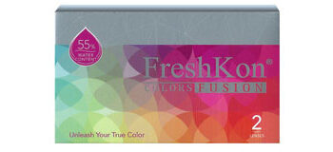
Brand | DIOR
Model Name | FRESHCON
Price | RS 3800
PRODUCT DETAILS

